

Aldabra Research Station

Research Officer’s Annual Report

2008

Compiled by: Naomi Doak

Contents

Contents 2
1.0: Summary 2
2.0: Climate 6
3.0: Turtle Monitoring 8
3.1: Track counts along external beaches (Green turtles) 8
3.2: Track counts along lagoon beaches (Hawksbill turtles) 10
3.3: Tagging of Nesting Turtles 10
3.4: Tagging of juvenile turtles 10
4.0: Aldabra Tortoise Monitoring Programme 11
4.1: Introduction 11
5.0: Bird Monitoring 14
5.1: Land birds 14
5.2: Wader counts 17
5.3: Sea birds 18
6.0: Subsistence Fishing 19
7.0: Robber Crabs 21
8.0: Marine Mammals 22
8.1: Dugongs 22
8.2: Whales and dolphins 22
9.0: Vegetation Monitoring 23
10.0: Goat Eradication Project 24
11.0: Rangers Projects 25
12.0: Departmental Issues 26
12.1: Staff 26
5.0: Comments from RO 27

1.0: Summary

As I am a relatively new research Officer on Aldabra and I commenced working in this position in December 2008 the following Annual Report has been compiled from the limited number of monthly reports completed during 2008 and from the data bases present at the station.

It has been a difficult time over the last year trying to keep the monitoring programmes on track. This has been influenced by boat and engine problems and the heightened tourist activity on the atoll in the last few months of the year. It was also due to the (double) change of Research Officer which included a number of months when there was no research officer on the atoll which has unfortunately meant that the monitoring programmes have had to take a back seat and monthly reports were often not completed. Since my arrival I have done my best to catch up on monthly reports for the last three months of the year and to continue with comprehensive and timely reports for the start of 2009. I have to apologise for the lateness of this annual report.

During 2008, despite the staff changes and the absence of a Research officer for some months meteorological data (temperature and rainfall) was collected at the research station on a daily basis and monthly rainfall totals were collected for all rain gauges around the atoll (Figure 1). As in previous years a considerable proportion of the time spent undertaking monitoring activities on the atoll was dedicated to collecting valuable data on turtles. This included emergence counts for nesting green and hawksbill turtles, tagging of nesting green turtles, emergences of nesting hawksbill turtles, and juvenile green and hawksbill turtles in the lagoon. A volunteer project commencing in November also investigated the number and distribution of foraging turtles in the lagoon and revealed some interesting trends in the sex ratio of foraging turtles on the sea grass beds in the lagoon area behind Picard. Twice monthly assessments of beach accessibility were also undertaken along Settlement Beach as part of the turtle monitoring conducted on the atoll.

Monthly data was collected for all the tortoise transects and land bird point counts in various locations around the atoll (Figure 1). Twelve transects are monitored for tortoises and seven of these are also used for the land bird point counts with the number of points on each ranging from four to nine. Monitoring of birds on the atoll is no restricted to the land birds and counts of the number and species of waders are also carried out. These were primarily completed along settlement beach on Picard at least twice every month with counts also being conducted along the coast from Dune June Louis to Dune D’Messe when possible once a month. When possible counts of the number of crab plovers were conducted at Ile Moustique and the red-tailed tropic birds nesting on the islets on the inside of the lagoon adjacent to Picard were also monitored for nesting activity. For the first time on the atoll targeted surveys and a specific project investigating the presence of the Madagascan Pond Heron commenced to coincide with the reported breeding period for this species on the atoll.

In April 2007 vegetation monitoring was initiated along the back path on Picard and this was continued into 2008. Focusing on the phenology of common species along the transect this monitoring activity underwent a number of changes during 2008 but continues to gather important information on the vegetation and observations of interactions between potential pollinators as well as species feeding on the vegetation. Considerable time and effort was also spent throughout the year monitoring the number and size of coconut crabs along the back path and coastal path tortoise transects on Picard. This monitoring was conducted 2 – 4 times a month and continues to provide large amounts of data on the abundance, size and distribution of coconut crabs along these two transects.

While the majority of monitoring programmes on the atoll concentrate on the terrestrial environment in one way or another a number of Marine monitoring programmes were conducted and continued in 2008. The transect first established by the AMP opposite the settlement at the research station was monitored for butterfly fish species presence and abundance on numerous occasions throughout the year and data on fish catches was collected following all subsistence fishing. Observations of whales, dolphins and dugongs were also recorded and provide valuable information on the species frequently sighted around the atoll as well as the seasonality of particular species.

2008 was a busy year on Aldabra, in terms of monitoring activities, staff changes and also visitors. An increase in tourist activity saw the final months of the year pass with days busy with tour groups and cruise ships. It was also a busy year in terms of visiting researchers with numerous groups arriving on the atoll to conduct important research on a wide variety of projects including Mosquitoes and bats. The year also welcomed another visit from the AMP to conduct surveys and monitoring at established sites around the atoll.

Figure 1: Map of Aldabra Atoll with camps and locations of monitoring transect/activities.

2.0: Climate

Daily temperature readings are taken from the Stevenson Screen at the station. These include dry and wet bulb temperature at 8:00 am in the morning, when all readings are taken, and the maximum and minimum temperatures for the previous 24 hours. Mean monthly temperatures based on these daily readings are provided in Table 1. Note that late on October a giant tortoise knocked over the Stevenson screen breaking all the thermometers and requiring a replacement screen to be sent from Mahé. No temperature readings were possible during this time and the replacement minimum thermometer was also damaged and no recordings could be made in December for this parameter. Perhaps the most informative of these readings is the maximum daily temperature which gives an indication of the warmest temperature experienced at the station. For this reason the maximum temperature recorded throughout each month is also included Table 9. Any overall increase in temperatures at the station will be reflected in an increase in the maximum temperature recorded each day as well as the overall mean maximum temperature. While any comparison between maximum temperatures is relatively meaningless over short temporal periods both of these parameters for 2007 have been included in this report to provide a comparison in any trends as far as the hottest months of the year. In 2008 the months of January, February and March all recorded the highest mean maximum temperature while in 2007 these three months recorded the lowest mean maximum temperature with December recording the highest mean for 2007.

Table 1: Mean monthly temperatures for 2008, Picard weather station.
 | Jan | Feb | March | April | May | June | July | August | Sept | Oct | Nov | Dec
dry bulb | 27.7 | 27.7 | 27.6 | 27.3 | 26.8 | 25.3 | 24.3 | 24.6 | 25.4 | 26.5 | NA | 28.9
wet bulb | 26.8 | 26.5 | 26.3 | 26.2 | 24.9 | 23.8 | 22.7 | 22.8 | 23.7 | 24.7 | NA | 26.9
daily max | 35.5 | 35.5 | 35.5 | 32.8 | 31.6 | 29.5 | 28.6 | 28.5 | 29.6 | 30.6 | NA | 32.8
daily min | 25.9 | 25.8 | 25.7 | 25.3 | 25.2 | 23.6 | 17.6 | 18.2 | 18.6 | 19.4 | NA
Max daily maximum | 35.8 | 35.5 | 35.5 | 35.5 | 31.6 | 33.0 | 33.0 | 29.5 | 30.6 | 32.1 | NA | 34.8
2007
mean max | 33 | 33.21 | 33.6 | 35.14 | 35.22 | 35.37 | 35.31 | 35.37 | 35.4 | 35.37 | 35.4 | 35.5
Max daily maximum | 33.1 | 33.5 | 34.8 | 35.5 | 35.5 | 35.5 | 35.4 | 35.4 | 35.4 | 35.5 | 35.5 | 35.5

Daily rainfall data is also collected at the research station. Figure 2 shows the total monthly rainfall for each month of 2008 as well as depicting three of the temperature variables collected each day. January was by far the wettest month of the year in 2008 with the highest total monthly rainfall. As mentioned above January was also one of the three months that experienced the highest mean maximum temperature (35.5ºC) as well as recording the day with the highest maximum temperature (35.8ºC). In contrast to the high rainfall recorded in January, October recorded the lowest rainfall for the year. This is similar to 2007 when October also recorded the lowest rainfall.
Rainfall totals vary considerably around the atoll and there is no obvious or consistent pattern in the amount of rainfall that falls each month across the 12 locations where rainfall is recorded. Figure 3 shows the monthly rainfall recorded at these 12 locations. It shows the total rainfall for the past four years while also showing the mean monthly rainfall recorded at each location for 2008. In 2008 Middle Camp recorded the highest total amount of rainfall as well as the highest mean monthly rainfall. This is unlike previous years where Middle Camp often recorded the lowest total rainfall (e.g. 2006).

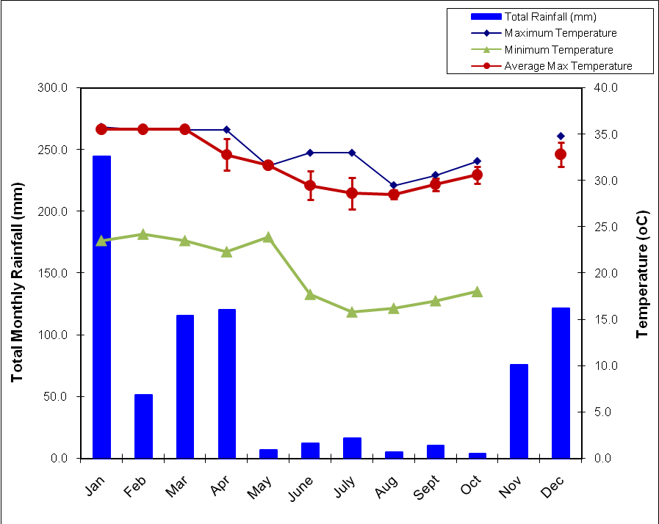
Figure 2: Total Monthly Rainfall and Average Maximum Temperature for Picard, Aldabra (error bars are standard deviation).

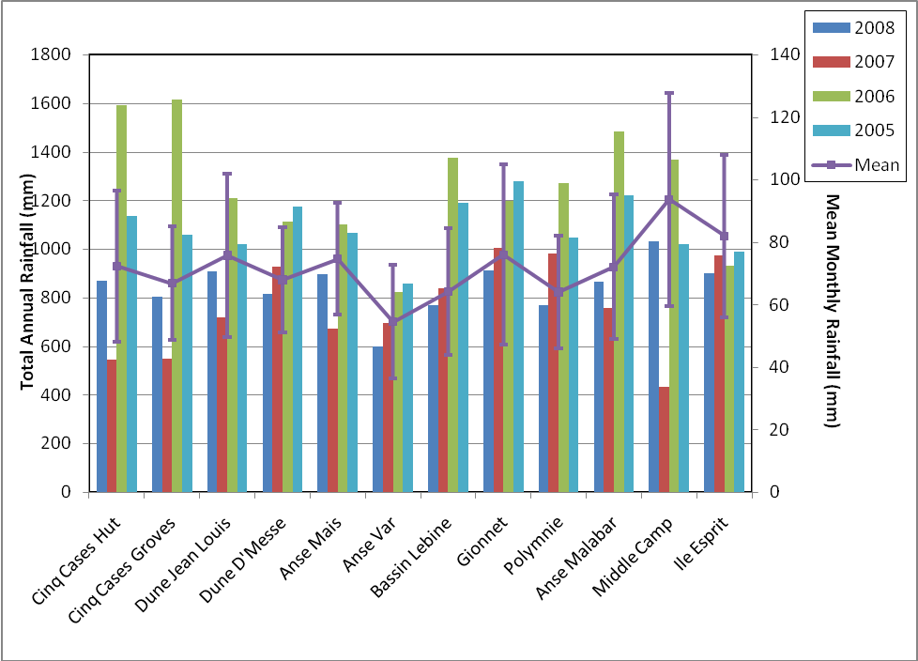
Figure 3: Total annual rainfall 2005 – 2008 and mean monthly rainfall for 2008 (error bars are standard error) for the rain gauge locations around the atoll.

3.0: Turtle Monitoring
Comprehensive analysis of the turtle monitoring data is not conducted here on Aldabra but is usually undertaken by Jeanne Mortimer. Jeanne is currently in the process of a detailed comprehensive analysis of the considerable amount of data collected on the turtles at Aldabra. I am unsure if this analysis includes the most up to date data from 2008 but detailed analysis has not been undertaken here and the results presented are a summary of the large amounts of data collected.

3.1: Track counts along external beaches (Green turtles)
A total of 353 counts were performed along Settlement beach in 2008, producing what is to date the most complete set of daily track counts for any year since the commencement of turtle monitoring. On each of these occasions the number of emergences was recorded with tracks being placed into one of three categories, very fresh (VF), half moon (HM) and emergence stopped by obstacle (ESBO).
Other beaches around the atoll are also checked for emergences and tracks counted on a regular basis. In each of the location groups (West Grande Terre, Cinq Cases, Dune Jean-Louis, Dune D’Messe, Northern Beaches and Anse Var) turtle track counts were conducted at least monthly. The only exceptions to this being the Cinq Case region where there was no track count conducted for February, March and December.

Settlement Beach is divided into four zones where emergences are recorded. Zone 4 recorded the largest number of emergences in 2008 in all three categories of track recorded; 1567, 98 and 357 very fresh, half moon and emergence stopped by obstacle respectively (Table 6). While this zone is by far and away the most visited zone of the beach with a total of 2022 emergences throughout the year, it is also the zone with the largest number of emergences that were stopped by obstacles, 357, with 17.6% of emergences being prevented by obstacles. While Zone 1 recorded the lowest number of emergences (137) only 0.2% of these were prevented by obstacles.

Table 6: Turtle tracks observed on Settlement Beach, Picard
 |  | Jan | Feb | Mar | Apr | May | June | July | Aug | Sept | Oct | Nov | Dec | Total
Zone 1 | VF | 3 | 15 | 8 | 6 | 13 | 22 | 17 | 10 | 3 | 4 | 6 | 16 | 123
 | HM | 0 | 1 | 1 | 1 | 2 | 1 | 2 | 1 | 1 | 0 | 0 | 1 | 11
 | ESBO | 0 | 0 | 0 | 0 | 0 | 1 | 1 | 0 | 0 | 0 | 0 | 1 | 3
Zone 2 | VF | 41 | 49 | 44 | 96 | 96 | 133 | 110 | 122 | 79 | 18 | 26 | 39 | 853
 | HM | 1 | 3 | 2 | 7 | 1 | 4 | 8 | 1 | 3 | 1 | 3 | 3 | 37
 | ESBO | 1 | 3 | 0 | 1 | 2 | 0 | 0 | 0 | 0 | 1 | 0 | 4 | 12
Zone 3 | VF | 44 | 58 | 98 | 110 | 139 | 134 | 128 | 120 | 70 | 49 | 17 | 37 | 1004
 | HM | 2 | 6 | 5 | 10 | 7 | 8 | 12 | 4 | 0 | 2 | 5 | 4 | 65
 | ESBO | 5 | 4 | 7 | 11 | 5 | 5 | 3 | 5 | 3 | 0 | 4 | 7 | 59
Zone 4 | VF | 71 | 117 | 214 | 244 | 233 | 207 | 153 | 102 | 96 | 77 | 22 | 31 | 1567
 | HM | 1 | 7 | 15 | 14 | 10 | 12 | 11 | 12 | 3 | 6 | 2 | 5 | 98
 | ESBO | 9 | 16 | 28 | 51 | 47 | 54 | 45 | 38 | 29 | 20 | 13 | 7 | 357
Total |  | 178 | 279 | 422 | 551 | 555 | 581 | 490 | 415 | 287 | 178 | 98 | 155

Very fresh tracks are those recorded to have involved some level of digging in attempts to lay eggs. While there is no differentiation in the emergences that have successfully laid a clutch of eggs and those that have involved digging of a body pit with no eggs being laid. Figure 4 shows the average number of very fresh emergences recorded in each zone of settlement beach for each month of 2008. Emergence data for settlement beach in previous years has shown that the seasonality related to nesting activity of green turtles is dynamic with the peak in nesting activity varying slightly from year to year. In 2007 this peak in activity was in March which was followed by a incremental decline until September and December with the lowest average number of emergences. In 2006 the peak in emergence activity was in May. In 2008 the peak in emergence activity in Zone 4 was in April (Figure 4) although as is evident from the large standard deviations the number of very fresh tracks recorded varied quite considerably and there is very little difference between the average number of emergences recorded from March through to June. Error bars were not placed on the average emergences for the other zones as the large size of the standard deviations and the format of the graph would have made it difficult to read the mean values for each zone in each month.
As can be seen in Figure 4 it is the number of emergences in Zone 4 which drives the position of the peak emergence time as there is no identifiable peak in nesting activity in the other three zones along settlement beach. In fact when all very fresh emergences are combined for the four zones on settlement beach in 2008 June has the highest average number of emergences (Table 7).

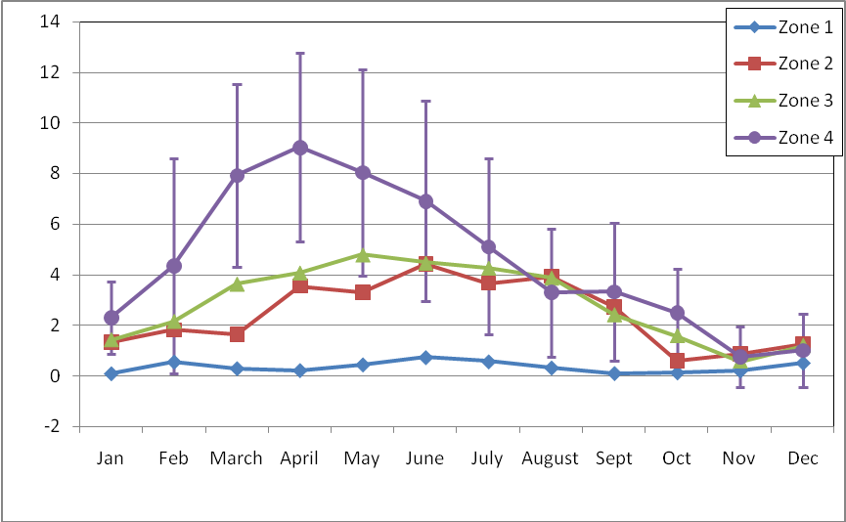
Figure 4: Average monthly number of very fresh (VF) emergence tracks recorded in each beach Zone on settlement beach in 2008 (error bars are Standard deviation).

The number of emergences recorded at other beaches around the atoll show a similar pattern to that seen on Settlement Beach (Table 7). Peaks in nesting activity were observed during the same months with an obvious peak in May and June. It should be noted that the very high averages for some areas, in particular West Grande Terre and Dune Jean Louis is an artefact of the number of beaches surveyed and the number of times each area was monitored throughout the month. For example West Grande Terre includes track counts for 22 beaches and while each is relatively short compared to Settlement beach the total number of tracks recorded often exceeds that detected on Settlement beach for the same day. In addition to this while Settlement beach is surveyed each day and so the average is calculated for each day of the month the other beaches may have only been monitored once or twice each month. As a result the average emergences for the other beaches are monthly averages determined by the number of monitoring events while effectively that for Settlement Beach becomes a daily average.

Table 7: Mean monthly number of turtle tracks observed for all beaches around the Atoll
 | Jan | Feb | Mar | Apr | May | June | July | Aug | Sept | Oct | Nov | Dec
Settlement | 5.1 | 8.2 | 11.7 | 15.2 | 15.5 | 16.5 | 13.2 | 11.4 | 8.3 | 4.8 | 2.4 | 4.0
West Grande Terre¹ | 18.0 | 35.8 | 43.5 | 56.0 | 71.3 | 92.0 | 71.3 | 44.0 | 43.0 | 15.0 | 11.0 | 23.0
Dune D’Messe² | 3 | 1.5 | 6 | 3 | 1 | 4 | 0 | 0 | 0 | 1 | 2 | 0
Dune J-L³ | 5 | 11 | 21 | 19 | 24 | 30 | 17 | 17 | 6 | 4 | 6 | 3
Cinq Cases⁴ | 0 |  |  | 1 | 1 | 0 | 0 | 0 | 0 | 0 | 0
North⁵ | 6.5 | 2.5 | 15 | 17 | 21 | 22 | 10 | 17 | 12 | 3 | 1 | 1
Anse Var⁶ | 0.5 | 0 | 0 | 0 | 1 | 0 | 0 | 1.5 | 0 | 0 | 0 | 0
¹ Beaches included in count – 2,3,4,5,6,7,8,9,10,11,12,13,14,15,15.5,16,17,17.5,18,19,20,21. FF tracks not recorded.
² Beaches included in count – 23, 24, 25, 26, 27, 28.
³ Beaches included in count – 29, 30, 31, 32, 33, 34, 35, 36. FF only recorded on 29, 30, 31.
⁴ Beaches included in count – 37, 38, 38.5, 39. FF not recorded.
⁵ Beaches included in count – 40, 41, 42, 43, 43.5, 44, 45, 46, 51, 55. FF only recorded on 40, 41, 42, 43. Anse Var included
⁶ Beaches included in count – 55 only. Anse Var counted in North beach counts as well as in its own count.

3.2: Track counts along lagoon beaches (Hawksbill turtles)

Hawksbill turtles on Aldabra nest only on the inner lagoon beaches. Breeding activity is primarily restricted to the period between September and March and during this time attempts are made to check these beaches once a month.

Track counts on the inner lagoon beaches for Hawksbill emergences were conducted on only three occasions in 2008. Problems with boats, high staff turnover and the absence of a Research Officer for much of the appropriate time for these counts meant that they were restricted to three occasions early in the year, 1 in January and 2 in February. On all three of these counts the majority of beaches could not be properly included as there was not sufficient sand or beach for emergence of nesting adults. On the one occasion in January one very fresh track was detected on beach 48a and one fairly fresh track also on this beach, while on the second count in February only fairly fresh tracks were detected with one on beach 48a and another on 50a.

3.3: Tagging of Nesting Turtles
Tagging of nesting turtles was carried out on a number of beaches around the atoll during specific tagging activities on Settlement beach or opportunistically during other monitoring at other beaches around the atoll. A total of 378 individual turtles were recorded during these activities. This included 219 individuals that were newly tagged in 2008 with the remaining 159 already having at least one tag present. The nature of this data base and activity means that turtles that were encountered at other times but had no tag applied or did not already have a tag are not recorded so no information on the percentage of individuals encountered during nesting activities that are not tagged or have no tags is unavailable.
Tagging of nesting turtles allows some information on the number of times females return within a season. As patrols for nesting turtles are not carried out every night any data on the number of returns is at best a minimum number of emergences. In 2008 of the turtles detected with tags (returning turtles) 42 had been tagged for the first time in 2008. One of these individuals was detected a total of 5 times, including the initial tagging event. Four others were first tagged in 2008 and returned another four times. Seventeen of the turtles individually identified were tagged during previous years and were identified in 2008.

3.4: Tagging of juvenile turtles
Juvenile turtles are tagged on Aldabra during turtle “rodeo” activities in the lagoon. In 2008 these were conducted at least once every month with the only exceptions being March and November when no rodeos were held. When juvenile turtles are caught they are weighed, measured and tagged if they have not already been tagged. A total of 104 juvenile turtles were caught in 2008 with 66 of these being Green turtles and the remaining 38 Hawksbills. Six percent of the green turtles caught were recaptures and 47% of the hawksbills were also recaptures.

4.0: Aldabra Tortoise Monitoring Programme

4.1: Introduction
Data on the giant tortoises on Aldabra has been collected since 1998. This information includes the number, sex and size of individual tortoises recorded along 12 transects around the atoll (Figure 1). This information is collected, when possible, on a monthly basis providing valuable information on the population size, structure and distribution of this species around the atoll. It also allows for annual and monthly variations in these parameters to be investigated.
There are currently two models used to look at the population of tortoises on the atoll; Bourns’ and Rainers’. Both of these require updates to the files and links used for the final calculations before results can be presented. This will be worked on for the 2009 annual report and is commented on in the RO comments for this report. Results presented below are summary results from the four main areas of the atoll where transects are located; Picard (3 transects), Cinq Cases (3 transects), Malabar (3 transects) and Grande Terre (3 transects).

Picard
Tortoise monitoring was conducted on Picard for all three transects once each month. Anse Var consistently records the lowest number of tortoises along the transect and individuals in this part of Picard are on average smaller than those detected on the other two transects, Coastal and Back Path (Figure 5). While the coastal transect often records a higher number of individuals it should be noted that the width of this transect is 20 m (10 m on each side of the transect) while for all other tortoise monitoring transects on Aldabra the width is 10 m (5 m on each side of the transect). This will not only influence the number of individuals recorded but also the mean size as the increased sample size will influence the calculation of the mean and any variation around this.

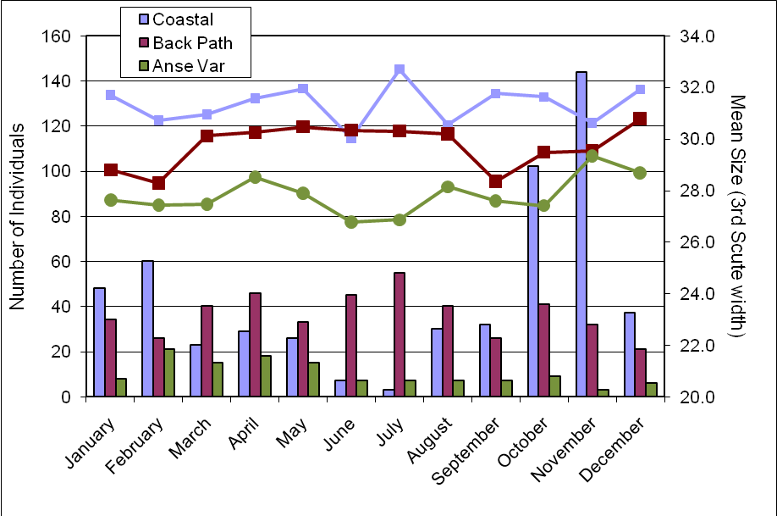
Figure 5: Number of individuals (columns) and mean size (line) as determined by the width of the third scute for the three giant tortoise transects monitored at Picard.

Malabar
Tortoise monitoring was completed at the three transects on Malabar each month of 2008. The coastal transect at Middle Camp consistently records the lowest number of individuals of all three transects while the transect at Malabar camp records the highest number of individuals and individuals with the highest mean size. Despite the Malabar transect recoding the highest number of animals, these numbers were mostly below the numbers recorded on Picard and the mean size was also smaller than those recorded on any of the three transects on Picard.

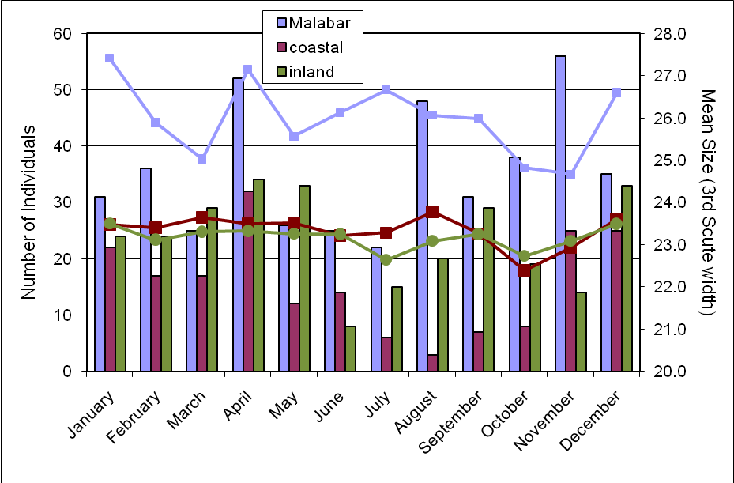
Figure 6: Number of individuals (columns) and mean size (line) as determined by the width of the third scute for the three giant tortoise transects monitored on Malabar.

Grand Terre – Cinq Cases, Dune Jean Louis, Dune D’Messe
Historically monitoring of the Giant tortoise population on Aldabra has shown that the area around Cinq Cases on Grande Terre has the highest number of individuals and these tend to be of a smaller size than in many of the other areas of the atoll. The data collected on all transects on Grande Terre during 2008 showed the same trends with the transect at Cinq Cases Coco and Dune D’Messe Coastal consistently recording the largest number of individuals. All 6 transects on Grande Terre recorded individuals of a much smaller size than those recorded on the transects on Picard and also Malabar. Individuals on the Cinq Cases Groves transect tended to be the smallest of any transect with many of these individuals falling under the size threshold used for determining the sex of individuals. In some locations this threshold perhaps needs reviewing and reconsidering and sexing of individuals in these locations where most animals are under the 20cm threshold should also be attempted and recorded where possible to obtain estimates of the sex rations of the local populations in these areas.

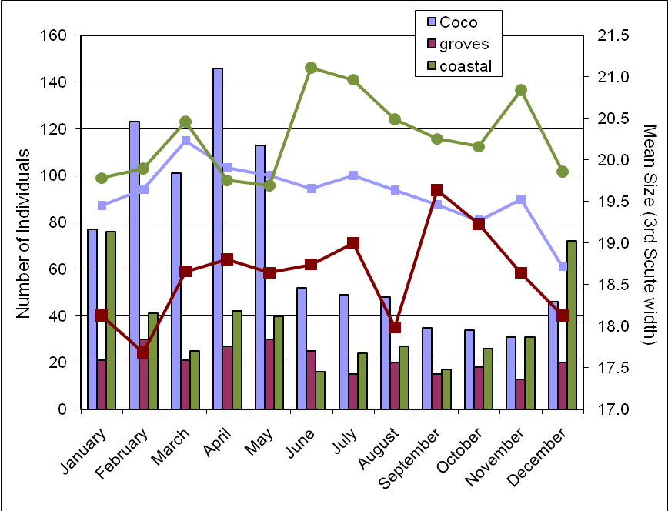
Figure 7: Number of individuals (columns) and mean size (line) as determined by the width of the third scute for the three giant tortoise transects monitored on Grande Terre, Cinq Cases.

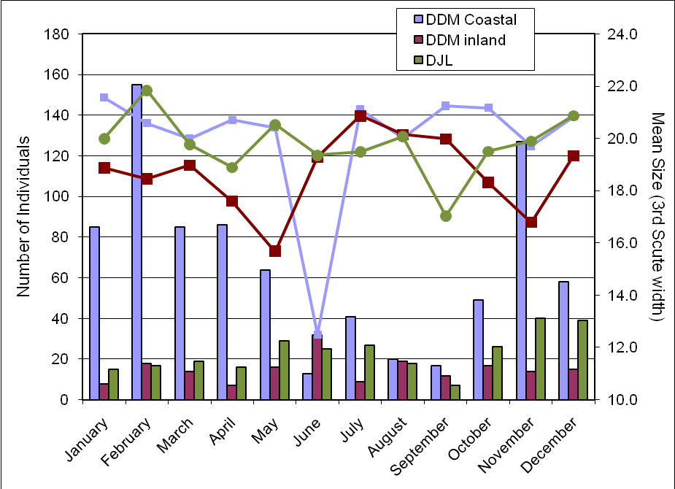
Figure 8: Number of individuals (columns) and mean size (line) as determined by the width of the third scute for the three giant tortoise transects monitored on Grande Terre, Dune Jean Louis and Dune D’Messe.
Population models
In 2004 Rainer von Brandis developed one of the population models available at the station to estimate the population size of the giant tortoise on Aldabra. This model is based on the trends in the tortoise numbers along the different transects (see RO Annual Report 2004 and 2005 for further information). As part of this model there is a Threshold for Potential Concern (TPC) was estimated. This threshold is primarily based on the trends in overall numbers of tortoises detected along the transects and factors in 1) the number of successive annual declines in tortoise numbers, 2) the percentage of variation in tortoise numbers between years and 3) the correlation coefficient of tortoise numbers over time. The level of concern in regards to the population trends in tortoises is then rated on a scale of one to three with one being no real concern and three being action is required. In 2008 analysis of the tortoise transect data in this model triggered a Level 1 concern (no action required) for 6 of the transects while the remaining 6 had no level assigned to them. The 6 that resulted in a Level 1 concern were Picard Coastal, Picard Back Path, Malabar, Dune D’Messe coastal, Dune D’Messe inland and Dune Jean Louis.

Unfortunately the Aldabran Giant Tortoise Monitoring Database designed by David Bourn in 2004 is not currently running in a way as to allow up to date population estimates from the data collected and entered. All monitoring data for the Giant Tortoises is currently entered into this data base as well as into the one developed by Ranier. However, the links in the access data base are mostly all out of date and broken and as such this data base can not currently be used to generate population estimates.

5.0: Bird Monitoring
There are a number of different monitoring activities undertake on Aldabra to monitor the bird populations. This includes monitoring focussing on land birds, waders and a number of the sea bird species on the atoll.

5.1: Land birds
The land bird monitoring involves seven of the tortoise transects located around the atoll (Figure 1). Along each of these transects point counts are conducted (counts of birds seen or heard over 4 minutes within a 25m radius of a specific point along the transect). The number of points monitored ranges from 4 – 9 depending on the location of the transect. The monitoring of land bird abundance around the atoll at these seven transects has been undertaken since 2002 and continues to provide valuable information, particularly in regards to the abundance of passerines. Point counts were conducted on all seven transects every month during 2008.

The total number of birds recorded across all point counts on all transects is shown in Figure 10. Displayed on a logarithmic scale it clearly shows that the most abundant species was the Souimanga Sunbird with the Malagasy Turtle dove the second most abundant species recorded. It is important to note that this figure does not account for differences in abundance between transects but shows the total number of individuals recorded. Despite this the sunbird was indeed the most abundant species across all transect locations. While the Malagasy Nightjar was not recorded on any of the transects, most likely due to the methods used and the low detection probability of this species during diurnal surveys.

Figure 11 shows the mean annual total number of birds recorded on the land bird transects from 2002 to 2007. It also shows the total number recorded for each species in 2008 on the same transects. The numbers recorded for 2008 are extremely similar to the average total number recorded for the previous 5 years and indicate no significant decrease or increase in the number of birds detected throughout the year. It does show a slight decrease in the number of pied crows detected at the point counts along the transects although their highly mobile nature could easily influence this along with the methods designed more specifically for passerines. The total numbers recorded for 2008 fall well within the variation in numbers for the previous 5 years. Standard erros was calculated for these totals but is not shown on the graph due to the logarithmic scale used to plot the number of birds recorded.

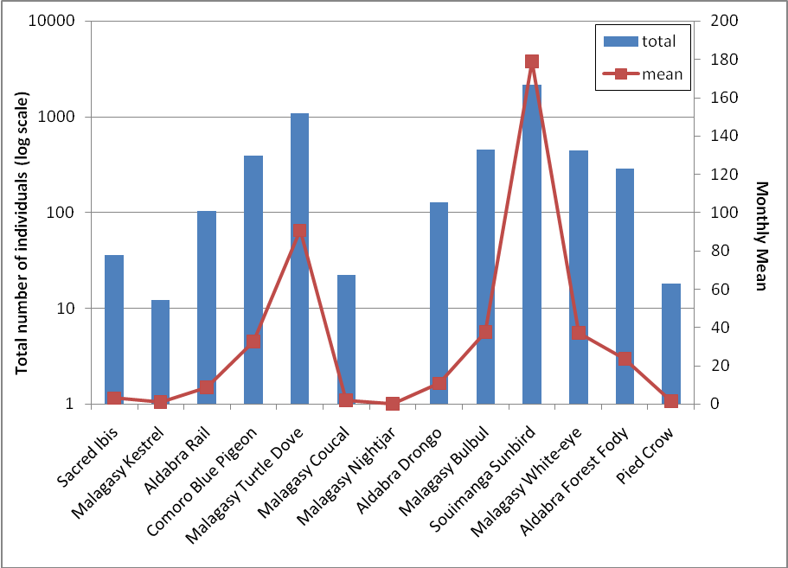
Figure 10: Total number and monthly mean number of birds recorded across all point counts on all transects fro 2008.

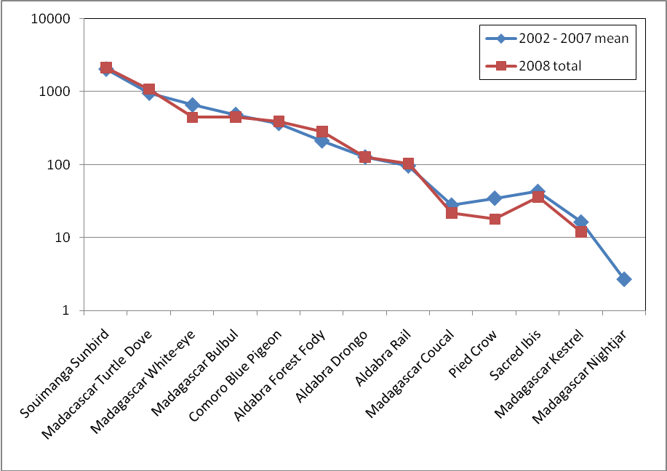
Figure 11:

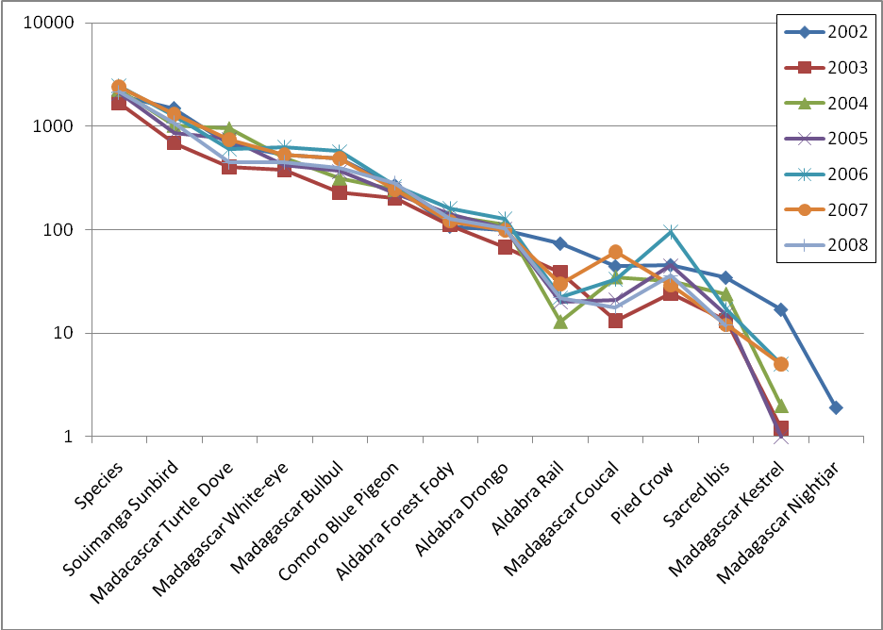
Figure 12:

Rail Monitoring

Monitoring of the rail populations on the individual islands of Aldabra is not currently undertaken. Previously this monitoring of the rail was conducted at a number of transects with the use of call play back tapes.

As with the previous annual report, the current monitoring of the rail population on Picard is restricted to sightings and counts of individuals recorded during the monthly land bird monitoring. The data gathered on the land bird point counts at the transect on Picard shows very little variation in the total number of birds recorded throughout the year. While the numbers for 2008 are higher than the previous year they are slightly lower than others for example 2006 and 2004.

Monthly totals for 2008 and 2007 show similar trends in the number of birds detected. These numbers are not presented for other preceding years as the data files for the land bird counts in previous years require significant editing to allow accurate calculation of values. This is particularly the case for calculation of monthly totals and averages. In point count methods such as these records of 0 birds in a particular species for a particular point along any one of the transects are important data points. These values have previously been excluded from the summaries and calculations of mean sightings and need to be included for an accurate representation of species distribution and abundance. Attempts will be made to rectify this for the next annual report as well as coming monthly reports.

Any trends evident in the monthly numbers and abundance may indicate post breeding increases in the population. These could then be used in conjunction with previous surveys to provide an indication of the most appropriate timing for targeted surveys of the rail populations, as suggested in the previous annual report and following the methods of Huxley.

 | 2002 | 2003 | 2004 | 2005 | 2006 | 2007 | 2008
TOTAL | 74 | 67 | 112 | 103 | 127 | 98 | 104

TOTAL | Jan | Feb | Mar | Apr | May | June | July | Aug | Sept | Oct | Nov | Dec
2008 | 7 | 8 | 8 | 10 | 11 | 9 | 15 | 13 | 7 | 5 | 4 | 7
2007 | 11 | 13 | 10 | 20 | 11 | 3 | 3 | 8 | 4 | 1 | 9 | 5

5.2: Wader counts

Table 10: Wader species and number of individuals seen off Settlement Beach.
 | January 2009 |  | February 2009
 | 20/1/09 |  | 5/2/2009 | 19/2/2009
Crab plover | 30 |  | 13 | 2
Dimorphic egret | 2 |  | 5 | 9
Greater sand plover | 1 |  |  | 2
Lesser sand plover |  |  | 2
Green-backed heron | 5 |  | 7 | 5
Grey heron | 1 |  | 2 | 2
Grey plover | 3 |  | 1 | 5
Ringed Plover |  |  | 2
Ruddy turnstone | 73 |  | 67 | 46
Sanderling | 23 |  | 20 | 23
Whimbrel | 2 |  |  | 3
Wood Sandpiper |  |  | 1

crab plover

flamingo

5.3: Sea birds

Red-tailed Tropicbird (Phaeton rubricauda) monitoring

Vagrant and unusual bird sightings

6.0: Subsistence Fishing

Table 12: Details of fishing trips conducted throughout 2008.
Species | Total number of fish | Total weight of fish | Mean weight per fish | Percentage of total catch
Emporers
Baksou | 14 | 9.20 | 0.66 | 0.42
Bawa / Malbawa | 1 | 0.80 | 0.80 | 0.04
Bekbek | 1 | 1.60 | 1.60 | 0.07
Gel Long / Bek Long | 1 | 2.10 | 2.10 | 0.10
Kaptenn Rouz | 135 | 299.15 | 2.22 | 13.53
Madanm Beri | 4 | 3.30 | 0.83 | 0.15
Groupers
Babonn Sesil | 2 | 5.50 | 2.75 | 0.25
Kwasan | 245 | 368.75 | 1.51 | 16.68
Madanm Dilo | 15 | 3.35 | 0.22 | 0.15
Vyey Babonn | 4 | 25.60 | 6.40 | 1.16
Vyey Galfa | 2 | 2.50 | 1.25 | 0.11
Vyey Goni | 4 | 32.50 | 8.13 | 1.47
Vyey Krab | 1 | 4.90 | 4.90 | 0.22
Vyey Masata | 69 | 158.90 | 2.30 | 7.19
Vyey Plat | 73 | 175.20 | 2.40 | 7.93
Vyey Sat | 3 | 5.30 | 1.77 | 0.24
Vyey Toukoula | 19 | 234.40 | 12.34 | 10.60
Vyey Zannannan | 26 | 69.30 | 2.67 | 3.14
Triggerfish
Bours | 5 | 7.50 | 1.50 | 0.34
Wrasses
Snappers
Terez | 3 | 2.00 | 0.67 | 0.09
Varavara | 191 | 352.35 | 1.84 | 15.94
TOTALS | 624 | 1409.85 | 2.26 | 63.78
Trawling
Zob Gri / Zob Ver | 8 | 21.80 | 2.73 | 0.99
Jacks/Pompanos
Galate | 6 | 80.80 | 13.47 | 3.66
Karang Ledan | 42 | 350.00 | 8.33 | 15.83
Karang Ver | 45 | 183.40 | 4.08 | 8.30
Tunas
Bonit | 21 | 128.00 | 6.10 | 5.79
Ton Ledan | 1 | 32.50 | 32.50 | 1.47
Ton Zonn | 1 | 4.00 | 4.00 | 0.18
Barracudas
Tazar | 8 | 136.51 | 17.06 | 6.18
TOTALS | 124 | 800.50 | 6.46 | 36.22

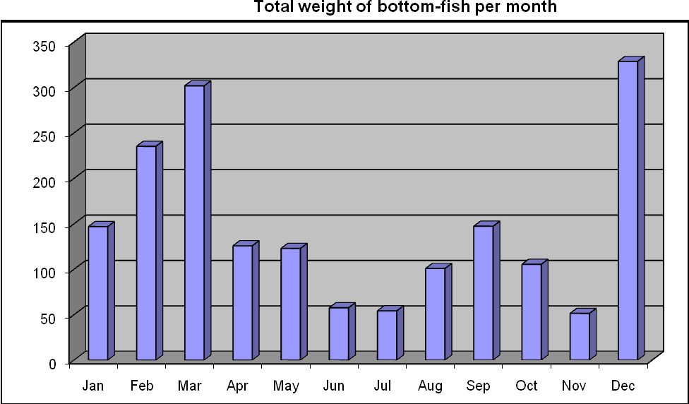

7.0: Robber Crabs
Robber crab monitoring was first instigated in October 2006 with an increase in the effort invested in this monitoring commencing in March 2007 by the then RO Pierre Pistorius. This monitoring has continued on a regular basis

8.0: Marine Mammals

8.1: Dugongs

8.2: Whales and dolphins

9.0: Vegetation Monitoring

10.0: Goat Eradication Project

11.0: Rangers Projects

12.0: Departmental Issues

12.1: Staff

Table 1: Name, position and engagement of research staff at the Aldabra Research Station.

Name | Post | Engagement / Location
Naomi Doak | Research Officer | Present at Station
Alex Underwood | Senior Ranger | Returned from leave
David Boodna | Ranger | Present at Station, On leave March
Stan Denis | Trainee Ranger | Present at Station
Jennifer Stockdale | Volunteer | Present at Station

5.0: Comments from RO

Tortoise files and models.

Robber crabs

